Phase-4 project planning
Date | 28-09-2026
Team ID | SWTID-2026-7624
Project name | Script-controlled ACL
Maximum marks | 4 marks

1. Project Planning
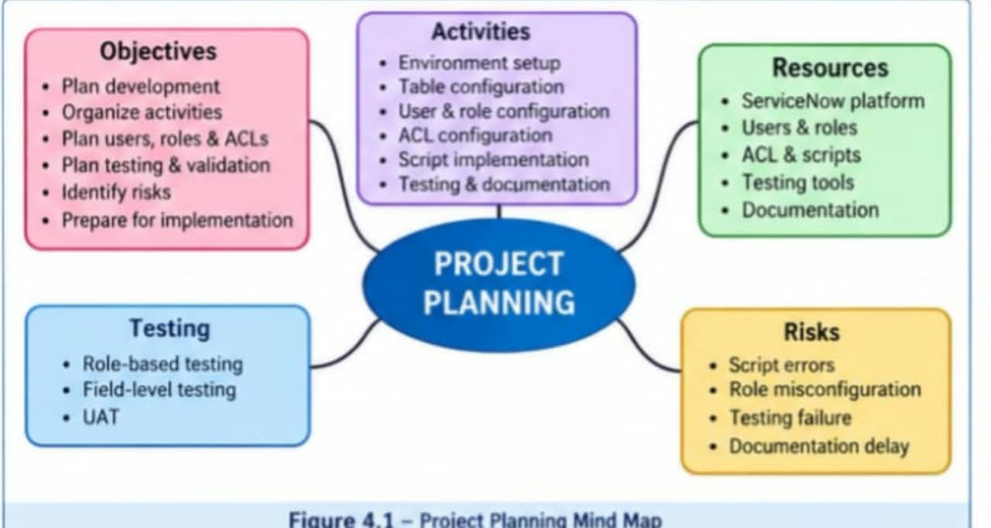
Project planning defines the activities, resources, schedule, milestones, responsibilities, and risks involved in implementing the Script-Controlled ACL system.
The purpose of this phase is to organize the project activities in a systematic manner and ensure that the development, testing, documentation, and deployment activities are completed properly.
2. Project Objectives
The main objectives of the project are:
To implement Script-Controlled ACL in ServiceNow.
To restrict record access based on user roles and field values.
To provide separate permissions for Read, Create, Write, and Delete operations.
To provide unrestricted access to administrators.
To test and validate the access-control mechanism.
To complete the project within the planned schedule.
3. Project Activities
The project is divided into several activities. Each activity is performed in a planned sequence.
The major activities include:
ServiceNow environment setup
Institution Details table creation
User and role configuration
ACL configuration
Script development
Testing and debugging
User acceptance testing
Documentation
Final deployment
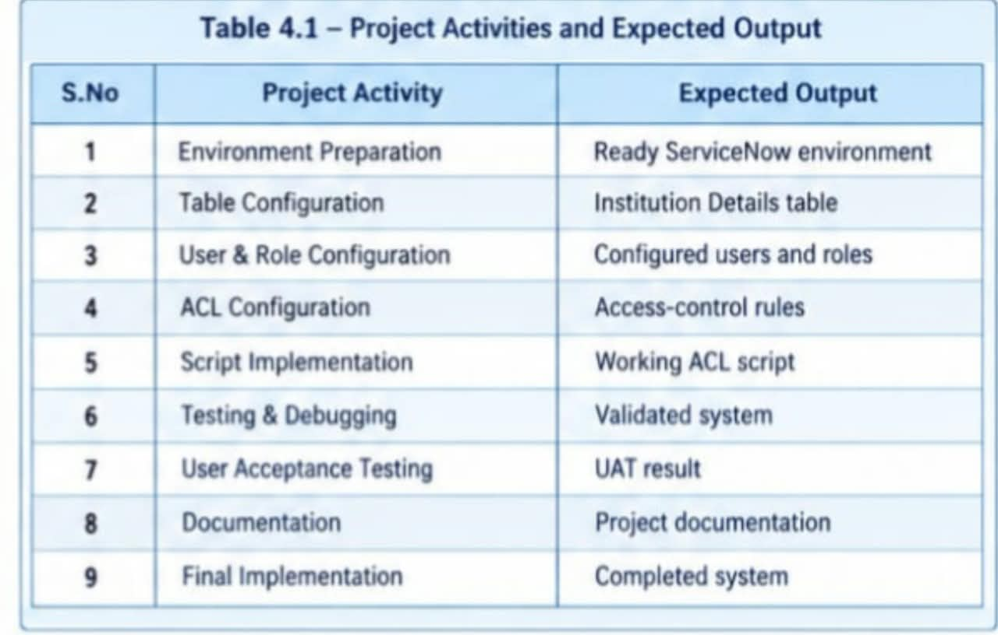

4. Project Schedule
The project schedule defines the approximate time required for completing each activity.
The activities are arranged according to their dependencies. Initial configuration is completed first, followed by implementation, testing, documentation, and deployment.
